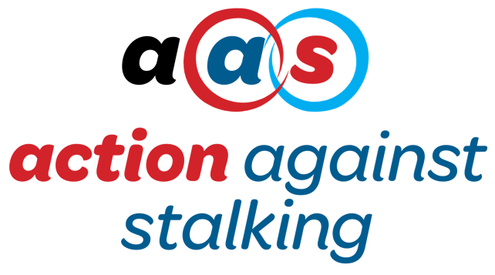

Complaints Policy & Procedure

- Statement of Intent

Action Against Stalking will deal with all complaints, whether from clients, other users, carers, volunteers, visitors, or members of the public, impartially and without favour. We recognise that mistakes can be made, and our aim is to learn from them and thereby improve our services. We also wish to satisfy complainants that their complaint has been taken seriously and that action has been taken when it is justified. This policy outlines the procedure through which those objectives will be achieved.

- Stage One

- Any client, user, carer, volunteer, visitor or member of the public who has a grievance in respect of the actions of a member of staff at Action Against Stalking should bring the matter to the attention of the CEO at linda.jones@actionagainststalking.org at the earliest possible opportunity. If possible, the grievance should be set out in writing.

- If the grievance is in respect of the CEO the person aggrieved should be asked to contact the Chairperson, but a brief record should be made of the complaint having been made and the action taken.

- The AAS member receiving the complaint must initially inform the Chairperson and then investigate the matter as quickly as possible, and in any case within seven working days. If there is any reason for delay beyond this time, the complainant should be informed in writing. If the delay is likely to be lengthy, the Chairperson should be informed.

- Following investigation, the matter should be discussed further with the complainant and a letter written to them, informing them of the outcome. If the complainant is satisfied that the matter has been resolved the person who is dealing with the complaint will report the facts, including the details of investigation and the outcome to the Chairperson in writing.

- Stage Two

- If the complainant is not satisfied with the outcome of the investigation and the matter remains unresolved, the grievance is to be forwarded to the Board and a Trustee assigned to investigate the matter. The Trustee will decide on any further action to be taken and inform the complainant in writing about what is going to happen.

- Once any further action is complete the Trustee will ensure that the person aggrieved will be notified of the outcome in writing.

- Stage Three

- If the individual remains dissatisfied the Management Committee will be asked to review the action taken.

- Principles

- All complaints must be taken seriously at the outset, regardless of the circumstances. This is particularly the case in respect of complaints about inappropriate behaviour towards a client. However, it is important that members of staff are protected from malicious complaints and any such allegations must therefore be carefully investigated.

- The purpose of the procedure is to resolve the matter to the satisfaction of the person making the complaint. The person investigating should therefore make every effort to determine what the complainant wants to happen.

- The person investigating may use any method to resolve the complaint that seems appropriate. However, if they are uncertain about the appropriateness of their actions, they should seek advice from the Chairperson.

- If a meeting is arranged between the aggrieved person and the member of staff concerned, it should be facilitated with a view to coming to some agreement. Both parties should be provided with documentation prior to the meeting, and they may be accompanied by a friend, or in the case of the employee, a work colleague. Each party should be given the opportunity to give an uninterrupted account of what happened, and the facilitator should then explore how the matter can be resolved.

- If the aggrieved person considers the grievance procedure to be inappropriate, or they need advice before discussing the matter with the member of staff, they may make representations direct to the Chairperson. However, unless the circumstances are exceptional, the Chairperson will normally refer the matter back to the CEO for investigation.

- The decision of the Management Committee will be final in the case of any action taken under Stage Three.

- All parties involved in the investigative process must be alert to the possible need to report the matter to the police if it appears that a criminal offence may have been committed. If the allegation relates to a possible serious criminal offence, advice must be sought immediately from the Chairperson.

- Document Complaints

- All correspondence and communication must be formally documented.

